Line-Object Collinearity

Definition
# Source: AI Source: Provided by: [Data Path: Persons Table -> ID Column: 1, Name_En Column: Motasem Essam] -> From: [ChatGPT] on [7/25/2026]
Line-Object Collinearity is a type of collinearity in which a geometric object lies on, or is aligned with, a common straight line.
Unlike ordinary point collinearity, which primarily describes several points lying on one line, line-object collinearity extends the idea to relationships involving points, line segments, and rays with a common supporting line.
For example, if point $P$, segment $\overset{‾}{AB}$, and ray $\vec{CD}$all lie on the same line $l$, then they have a common line-object collinear relationship:
$$P∈l, \overset{‾}{AB}⊆l, \vec{CD}⊆l$$
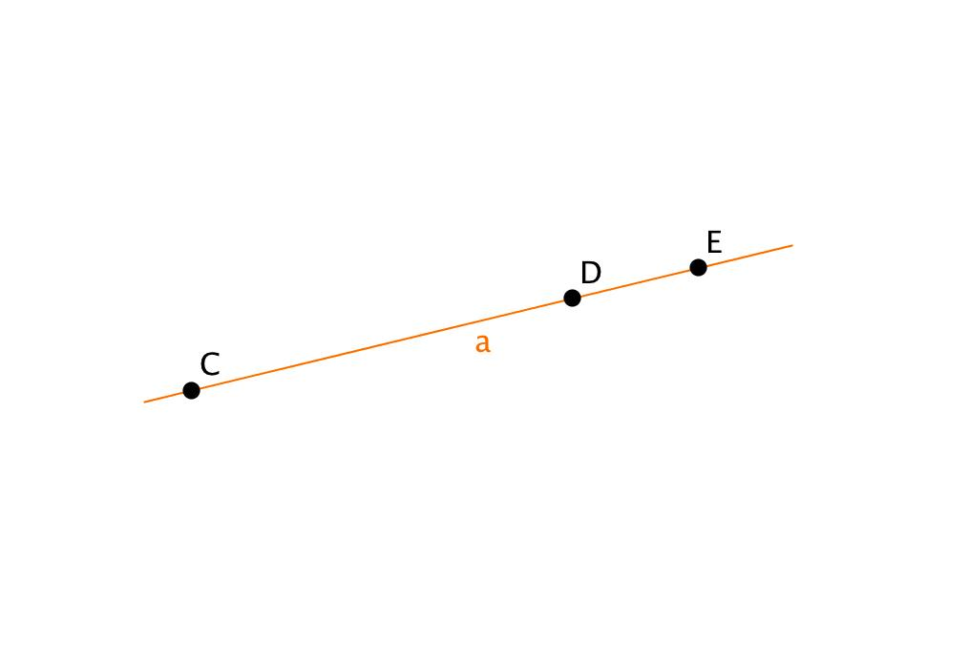
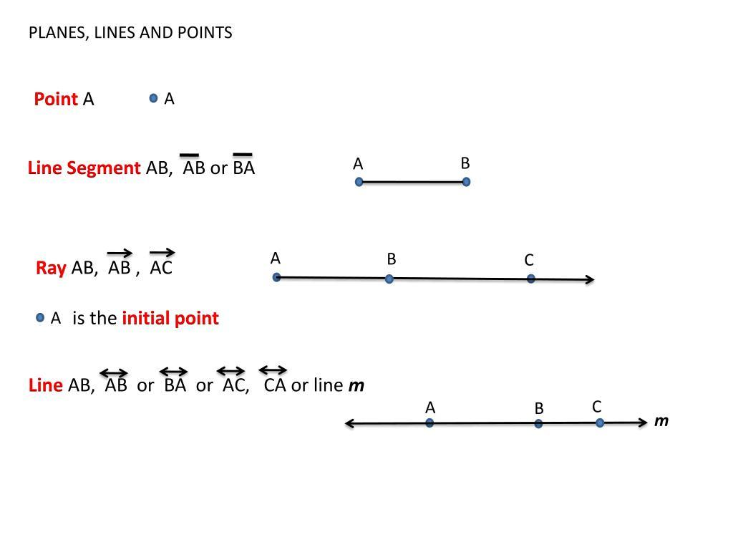
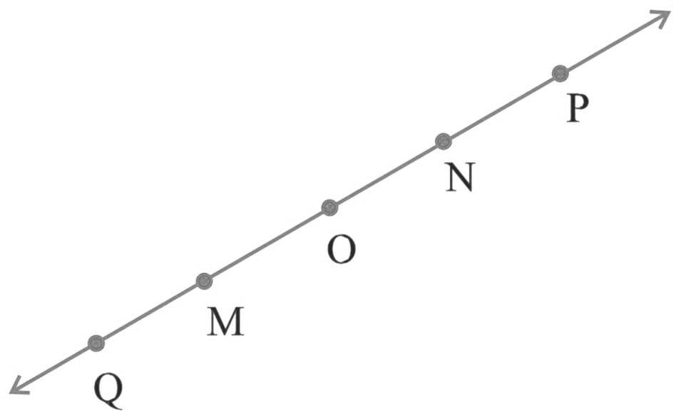

Purpose
# Source: AI Source: Provided by: [Data Path: Persons Table -> ID Column: 1, Name_En Column: Motasem Essam] -> From: [ChatGPT] on [7/25/2026]
Line-object collinearity is used to:
- Describe alignment between different types of geometric objects.
- Relate points, segments, rays, and lines through a common supporting line.
- Determine whether a geometric object belongs to a particular line.
- Analyze composite geometric constructions.
- Establish relationships between line segments and their endpoints.
- Connect point collinearity with line and segment containment.

Fundamental Concept
# Source: AI Source: Provided by: [Data Path: Persons Table -> ID Column: 1, Name_En Column: Motasem Essam] -> From: [ChatGPT] on [7/25/2026]
The fundamental idea is common supporting-line membership.
For geometric objects $X_{1},X_{2},…,X_{n}$, they have a line-object collinear relationship when there exists a line $l$that contains or supports them:
$$\boxed{X_{1},X_{2},…,X_{n}⊆l}$$
For a point, membership is written:
$$P∈l$$
For a segment:
$$\overset{‾}{AB}⊆l$$
For a ray:
$$\vec{AB}⊆l$$
Thus, the exact mathematical notation depends on the type of object.

Types of Line-Object Collinearity
# Source: AI Source: Provided by: [Data Path: Persons Table -> ID Column: 1, Name_En Column: Motasem Essam] -> From: [ChatGPT] on [7/25/2026]
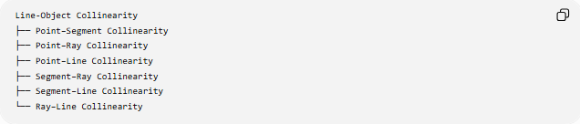
Line-Object Collinearity
├── Point–Segment Collinearity
├── Point–Ray Collinearity
├── Point–Line Collinearity
├── Segment–Ray Collinearity
├── Segment–Line Collinearity
└── Ray–Line Collinearity
These describe different combinations of linear geometric objects sharing a common supporting line.

1. Point–Segment Collinearity
# Source: AI Source: Provided by: [Data Path: Persons Table -> ID Column: 1, Name_En Column: Motasem Essam] -> From: [ChatGPT] on [7/25/2026]
A point and a line segment are line-object collinear when the point lies on the same supporting line as the segment.
For point $P$and segment $\overset{‾}{AB}$:
$$P∈\overset{↔}{AB}$$
This does not necessarily mean that $P$lies inside the segment.
For example:
P ●──── A ●────────● B
Here $P$, $A$, and $B$are collinear, but:
$$P∉\overset{‾}{AB}$$
The point is on the supporting line but outside the segment.

2. Point–Ray Collinearity
# Source: AI Source: Provided by: [Data Path: Persons Table -> ID Column: 1, Name_En Column: Motasem Essam] -> From: [ChatGPT] on [7/25/2026]
A point and a ray are line-object collinear when the point lies on the supporting line of the ray.
For ray:
$$\vec{AB}$$
the supporting line is:
$$\overset{↔}{AB}$$
A point $P$is collinear with the ray when:
$$P∈\overset{↔}{AB}$$
However, if we specifically require the point to belong to the ray, then:
$$P∈\vec{AB}$$
These are different conditions.

3. Point–Line Collinearity
# Source: AI Source: Provided by: [Data Path: Persons Table -> ID Column: 1, Name_En Column: Motasem Essam] -> From: [ChatGPT] on [7/25/2026]
A point and a line have a direct incidence relationship when the point lies on the line:
$$\boxed{P∈l}$$
For example:

P ●
────────────────────────────────
l
This is more precisely described as point-line incidence or line containment, rather than ordinary point-point collinearity.
For your taxonomy, it is useful to keep this distinction clear.

4. Segment–Ray Collinearity
# Source: AI Source: Provided by: [Data Path: Persons Table -> ID Column: 1, Name_En Column: Motasem Essam] -> From: [ChatGPT] on [7/25/2026]
A segment and a ray are line-object collinear when both lie on the same supporting line.
For:
$$\overset{‾}{AB}$$
and:
$$\vec{CD}$$
there exists a line $l$such that:
$$\overset{‾}{AB}⊆l$$
and:
$$\vec{CD}⊆l$$
They may be separated, touch, or overlap.

A ●────● B C ●──────────────→ D
────────────────────────────────────────
common line

5. Segment–Line Collinearity
# Source: AI Source: Provided by: [Data Path: Persons Table -> ID Column: 1, Name_En Column: Motasem Essam] -> From: [ChatGPT] on [7/25/2026]
A line segment is contained in a line when every point of the segment belongs to that line.
For:
$$\overset{‾}{AB}$$
and line $l$:
$$\boxed{\overset{‾}{AB}⊆l}$$
This is essentially a containment relationship.
For example:

A ●────────────● B
────────────────────────────────
l
The segment is part of the line.

6. Ray–Line Collinearity
# Source: AI Source: Provided by: [Data Path: Persons Table -> ID Column: 1, Name_En Column: Motasem Essam] -> From: [ChatGPT] on [7/25/2026]
A ray lies on its supporting line.
For ray:
$$\vec{AB}$$
its supporting line is:
$$\overset{↔}{AB}$$
and:
$$\boxed{\vec{AB}⊆\overset{↔}{AB}}$$
A ray and its supporting line therefore have the same direction and lie on the same straight path, although the ray contains only part of the line.

Common Supporting Line
# Source: AI Source: Provided by: [Data Path: Persons Table -> ID Column: 1, Name_En Column: Motasem Essam] -> From: [ChatGPT] on [7/25/2026]
The most important concept is the supporting line.
For a segment:
$$\overset{‾}{AB}$$
the supporting line is:
$$\overset{↔}{AB}$$
For a ray:
$$\vec{AB}$$
the supporting line is also:
$$\overset{↔}{AB}$$
Therefore:
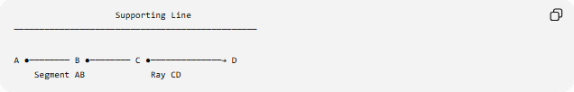
Supporting Line
────────────────────────────────────────────────

A ●──────── B ●──────── C ●──────────────→ D
Segment AB Ray CD
Different objects can occupy different portions of the same supporting line.

Example
# Source: AI Source: Provided by: [Data Path: Persons Table -> ID Column: 1, Name_En Column: Motasem Essam] -> From: [ChatGPT] on [7/25/2026]
Consider:
$$P\left(1 , 2\right) \\ \overset{‾}{AB}, A\left(2 , 2\right), B\left(5 , 2\right)$$
and:
$$\vec{CD}, C\left(7 , 2\right), D\left(9 , 2\right)$$
All these objects lie on:
$$y=2$$
Therefore:
$$P∈l \\ \overset{‾}{AB}⊆l \\ \vec{CD}⊆l$$
where:
$$l:y=2$$
Thus they have a common line-object alignment.

Important Distinction: Collinearity vs. Containment
# Source: AI Source: Provided by: [Data Path: Persons Table -> ID Column: 1, Name_En Column: Motasem Essam] -> From: [ChatGPT] on [7/25/2026]
These concepts are closely related but should not be treated as identical.
Collinearity
Focuses on alignment with the same straight line.
Containment
Focuses on whether one object is completely contained within another.
For example:
$$\overset{‾}{AB}⊆l$$
is a containment relationship.
The fact that $\overset{‾}{AB}$and another segment $\overset{‾}{CD}$have the same supporting line establishes their segment collinearity.
Thus:

Line-Object Collinearity
│
├── Common supporting line
│
└── Often expressed using containment

Line-Object Collinearity vs. Point Collinearity
# Source: AI Source: Provided by: [Data Path: Persons Table -> ID Column: 1, Name_En Column: Motasem Essam] -> From: [ChatGPT] on [7/25/2026]
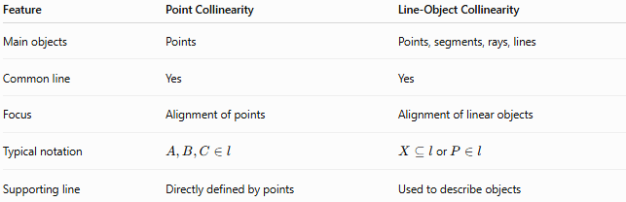
Feature | Point Collinearity | Line-Object Collinearity
Main objects | Points | Points, segments, rays, lines
Common line | Yes | Yes
Focus | Alignment of points | Alignment of linear objects
Typical notation | $$A,B,C∈l$$ | $X⊆l$or $P∈l$
Supporting line | Directly defined by points | Used to describe objects

Line-Object Collinearity vs. Parallelism
# Source: AI Source: Provided by: [Data Path: Persons Table -> ID Column: 1, Name_En Column: Motasem Essam] -> From: [ChatGPT] on [7/25/2026]
Two segments can be parallel without being line-object collinear.
Parallel:


A ●────────● B

C ●────────● D
Their supporting lines are different.
For line-object collinearity:

Collinear:

A ●────────● B──────● C────────● D
There is one common supporting line.
Therefore:
$$\boxed{\text{Same supporting line}≠\text{merely parallel}}$$

Relationship to Other Collinearity Types
# Source: AI Source: Provided by: [Data Path: Persons Table -> ID Column: 1, Name_En Column: Motasem Essam] -> From: [ChatGPT] on [7/25/2026]
Your complete hierarchy can now be organized as:
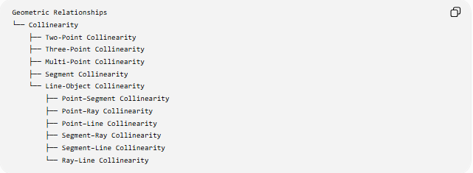
Geometric Relationships
└── Collinearity
├── Two-Point Collinearity
├── Three-Point Collinearity
├── Multi-Point Collinearity
├── Segment Collinearity
└── Line-Object Collinearity
├── Point–Segment Collinearity
├── Point–Ray Collinearity
├── Point–Line Collinearity
├── Segment–Ray Collinearity
├── Segment–Line Collinearity
└── Ray–Line Collinearity
Taxonomic note
There is some overlap between Line-Object Collinearity and Containment/Incidence. In a formal geometry knowledge base, it is useful to distinguish them by purpose:
- Collinearity → emphasizes common straight-line alignment.
- Incidence → emphasizes that objects meet or contain a common point.
- Containment → emphasizes that one object is inside or part of another object.
So, for example:
$$P∈l$$
is fundamentally an incidence statement, while:
$$A,B,C∈l$$
is normally discussed as point collinearity.

Key Properties
# Source: AI Source: Provided by: [Data Path: Persons Table -> ID Column: 1, Name_En Column: Motasem Essam] -> From: [ChatGPT] on [7/25/2026]
- Line-object collinearity involves linear geometric objects sharing a common supporting line.
- It can involve points, segments, rays, and lines.
- A point uses $P∈l$, while a segment or ray uses subset notation such as $\overset{‾}{AB}⊆l$.
- Objects do not have to touch to be aligned on the same line.
- Segments on the same supporting line can be separated, touching, overlapping, or coincident.
- Parallel objects are not necessarily collinear.
- Supporting lines are essential when comparing segments and rays.
- Line-object collinearity is closely related to incidence and containment but emphasizes linear alignment.

Conclusion
# Source: AI Source: Provided by: [Data Path: Persons Table -> ID Column: 1, Name_En Column: Motasem Essam] -> From: [ChatGPT] on [7/25/2026]
Line-Object Collinearity extends the concept of collinearity beyond sets of points to relationships involving points, line segments, rays, and lines that share a common supporting line. It is particularly useful for describing how different linear objects are aligned and for connecting collinearity with the related concepts of incidence, containment, intersection, and segment relationships.

